

To: Value and Performance Scrutiny Committee
City Executive Board

Date: 21st June 2011
22nd June

Report of: Head of Finance

Title of Report: PROVISIONAL OUTTURN REPORT FOR THE YEAR ENDED 31ST MARCH 2011

Summary and Recommendations

Purpose of report: This report sets out the forecast outturn position for the Council’s Capital and Revenue budgets for the year ended 31st March 2011 compared to the approved budget. In addition it provides explanations for variances from the outturn reported as at 28th Feb 2011.

Key decision? No

Executive lead member: Councillor Ed Turner

Policy Framework: Budget

Recommendation(s): 1) Note the outturn of £28.1m, this is £0.2m favourable to the approved Budget for 2010-11

2) Agree the transfer of the additional General Fund surplus of £0.2m to the Severance and HR Reserve

3) Agree to transfer £1.256m to the general fund working balance as per the approved 2010-11 Budget

4) Approve the carry forward requests recommended by CMT summarised in Table 7 and detailed in Appendix E attached

5) Approve the net transfers (to) / from provisions
- £(0.7)m for the General Fund,
- £(0.2)m for the Housing Revenue Account

6) Approve the net transfers (to)/ from earmarked reserves
- £(0.8)m for the General Fund
- £0.9m for the Housing Revenue Account
Movements to and from reserves are set out in Table 3 and detailed in Appendix B

1 EXECUTIVE SUMMARY

The report shows that:-

- The provisional outturn for the General Fund as at the 31st March 2011 is £28.1m; this £0.2m favourable to the 2010-11 approved budget after transfers to and from reserves. The outturn position is £76k favourable to the projected outturn reported as at February 28th 2011.
- The 2010-11 General Fund savings target was £2.7m of these savings £2.1m have been achieved in year (78%).
The Housing Revenue Account had a savings target of £1.1m, all savings have been achieved in year.
- As at 31st March 2011 the Housing Revenue Account forecast outturn shows a £282k surplus this is £218k less than the 2010-11 budgeted position.
- The Council’s actual capital spend was £24.9m in year this is compared to an approved budget of £34.3m. The £9.4m variation is due to both slippage and under spends largely within the HRA, as detailed in section 6.
- Investment interest performance for the year was 0.54%. The Bank of England base rate remains at 0.5%. The council monitors investment performance against the Libid rate which is currently 0.43%. During 2010-11 the council agreed a change in investment strategy. This change allows investments to the placed with additional counterparties and for longer periods. The results of this change can be seen during the last quarter of this year where there has been a steady, albeit small uplift on the rate of return. It is anticipated that the change in strategy will have greater impact in 2011-12
- As at 31st March 2011 the Council’s total General Fund sundry debts i.e. debt aged 31 days or more, stood at £4.6m 39% of which is aged 3 years or over. Housing benefit overpayments represent 94% of the debt aged over 3 years.
Debt associated with Housing Revenue Account current tenant’s stands at £610k, of this £10k is aged over 1 year. Debt associated with former tenants is £87k, the majority (£85k) is attributable to dwelling arrears.
- The Council’s accounts are still subject to audit. It is therefore the case that some of these figures may change as a result of that process.
2 GENERAL FUND PROVISIONAL OUTTURN

Appendix A provides an analysis of the provisional General Fund outturn broken down by directorate. Table 1 below provides a summary.

Table 1 – General Fund Forecast Outturn as at 31st March 2011

 | Approved Budget 10/11 | Expenditure 10/11 | Variance At Year End 10/11 | Variance as at Feb 28th 2011 | Variance to outturn as at Feb 28th 2011
 | £000's | £000's | £000's | £000's | £000's
Directorates
Chief Executive | 4,085 | 4,137 | 52 | 125 | (73)
City Regeneration | 7,286 | 6,219 | (1,067) | (709) | (358)
City Services | 9,048 | 9,418 | 370 | 650 | (281)
Finance & Efficiency | 3,396 | 3,547 | 151 | 120 | 31
Total Excluding SLAs And Capital Charges | 23,815 | 23,321 | (495) | 186 | (680)
SLAs And Capital Charges | (1,481) | (1,457) | 24 | 18 | 7
Corporate Line | 4,728 | 4,950 | 221 | (279) | 500
Net General Fund | 27,063 | 26,814 | (249) | (75) | (174)
(Use of)/ transfer to Balances | 1,256 | 1,256 | 0 | 0 | 0
Net Budget Requirement | 28,319 | 28,070 | (249) | (75) | (174)
External Funding | (16,766) | (16,767) | (1) | 0 | (1)
Council Tax | (12,447) | (12,558) | (111) | 0 | (111)
Less: Assumed Parish Precepts | 172 | 197 | 25 | 10 | 15
LABGI | (100) | 0 | 100 | 100 | 0
Collection Fund surplus | 0 | 0 | 0 | (111) | 111
Transfer to/from Reserves | 824 | 824 | 0 | 0 | 0
Total Funding Available | (28,319) | (28,304) | 15 | (1) | 16
General Fund Total | 0 | (234) | (234) | (76) | (159)
Working Balance
1st April 2010 | 3,140
Transfers in | 1,256
31st March 2011 | 4,396

The provisional outturn for 2010/11 is £28.1m, this is £0.2m favourable compared to the approved budget after a transfer of £1.256m to the general fund working balance, in accordance with the budget. Below is an explanation of the variances compared to the 2010-11 approved budget and the position reported as at 28th February 2011.

  - The Chief Executive’s Directorate is £52k over spent compared to the 2010-11 approved budget. This is £73k better than the position presented as at 28th February 2011

  - People and Equalities are £127k adverse to the approved budget; this is a result of a £171k pressure on employee costs, including £27k of unbudgeted costs relating to the employment of a unison representative, adverse costs associated with the implementation of the iTrent P&E system of £89k, a £41k pressure in occupational health. There is a further £17k across various expenditure and income lines. This is offset by a £191k under-spend against the employee training budget.

Compared to Feb 2011 Outturn
The position is £41k favourable to the reported February 2011 due to a larger under-spend against learning and development than anticipated.

- Law and Governance is £74k favourable due to a £43k LAA grant received in year, over achievement of legal hub income of £10k, and a £24k salary recharge arising as a result of staff time spent on new build projects (HRA) and St Giles fair. It is offset by £23k of electoral services costs that have been funded within the service rather then via a release from the electoral reserve. The remaining variance within the service relates to technical accounting adjustments processed at the year end.

Compared to Feb 2011 Outturn
The Law and Governance position is £31k favourable compared to the February position primarily as a result of £10k legal hub income and supplies and services spend being lower than anticipated.

- City Regeneration is £1.067m under spent compared to the 2010-11 approved budget. This is an improvement of £358k compared to the February position. The major contributors to the year end variance are:

    - Policy Culture and Communication is £106k favourable. This is largely a consequence of £126k of additional income and savings of £28k being made, predominantly against employee budgets due to vacant posts. However, this is offset by additional supplies and services costs of £54k, including £30k relating to Cowley Road Carnival and the Oxford United promotion parade. The remaining variance is a consequence of technical accounting adjustments processed within the service area at year end.

Compared to Feb 2011 Outturn
The Policy Culture and Communications position is £17k favourable to the position reported in February due to the application of an earmarked reserve to cover Town Hall equipment purchases.

    - City Development is £26k adverse. This is driven by a £162k favourable variance against salary costs as a result of vacant post being held across the year together with early retirements. Adverse variances offsetting this relate to £40k of unachieved savings relating to the Tourism cost centre, and £20k of additional costs associated with planning appeals. The Service also failed to achieve the budgeted level of Building Control income, falling £128k short.

Compared to Feb 2011 Outturn
The improvement of £73k compared to February 2011 is a result of salary savings and unexpected LAA grant received in the Tourism area.

  - Community Housing and Development is £923k favourable: This is driven by a £96k favourable salary variance driven by vacant posts during the year, £82k favourable within premises cost relating to property service charges in Communities and Neighbourhoods. The service has a £625k favourable variance related to Supplies and services; £433k of this is within Housing Needs driven by lease payments to landlords being lower than expected. Housing make lease payments to landlords in order to house those who are homeless with a priority need. Over the past year the Council has been offering people alternatives choices and encouraging them to find their own permanent accommodation as a consequence the need to pay leases on landlord owned accommodation has fallen, and as contracts come to end they are not being renewed. A further £74k of favourable variance relates to lower than budgeted Grant payments £30k and an over achievement of savings £44k.

The remaining variance is a net of under and overpayments across various cost centres within the service

Compared to Feb 2011 Outturn
Community Housing is £196k favourable to the position reported in February as a result of: Supplies and services Under-spends in Neighbourhoods and Communities £44k, under spend in the Grants area £37k, a £46k under spend on property lease payments. The remainder relates to additional income not forecast as at February 2011

- Corporate Assets is £64k favourable: this is as a result of additional lease income of £52k In addition there has been a reduction in the provision required for St Aldates rent of £85k. This has been offset by an increase in costs associated with late repairs, service maintenance, building insurance and estate costs of £120k. The remaining variance is made up of technical accounting adjustments processed at year end.

Compared to Feb 2011 Outturn
The Corporate assets position is £72k favourable to the position reported in February broadly as a consequence of the above.

- City Services is £370k over spent compared to the 2010-11 approved budget. This represents an improvement of £281k compared to the outturn reported as at 28th February 2011. The major contributors to the year end variance are:

- Environmental development is £29k favourable, This is a result of staff vacancies that have not been filled within the year

Compared to Feb 2011 Outturn
Environmental development is £16k adverse to the February 2011 position driven by additional carbon management costs to purchase smart meters at the end of the year

- Customer Services is £255k adverse this is driven by £180k of unachievable savings (note these have been adjusted for in the 2011-12 budget), £56k of unbudgeted spend relating maintenance of the CRM database, £82k adverse salary costs driven by a £228k over-spend on temporary staff offset by £146k favourable on permanent salary costs. In addition the service over-achieved against income budgets, £22k overachievement on court cost income and an additional sum received for Housing Benefit administration of £34k. The remaining variance can be attributed to technical accounting adjustments processed at year end.

Compared to Feb 2011 Outturn
Customer Services are £30k adverse to the February 2011 position this is driven by a £56k CRM database charge (unbudgeted in 2010-11) offset by additional court cost income received in the period.

- City Leisure is £641k favourable this is a result of a projected under spend on utilities related to the Leisure contract £105k;unspent additional sports development funding of £22k; £200k under-spend against the play project, £120k against salaries plus additional income in the Tree Maintenance team of £80k (additional internal income from Direct Services).
An enforced spending freeze across the Parks budget delivered further £114k of savings across supplies and services budgets.

Compared to Feb 2011 Outturn
City Leisure is £311k favourable to the February 2011 position primarily as a result of the £200k under spend within the Play project, a £51k under spend on Leisure management premises, and an additional £70k of income within the Parks area.

- Direct Services is £784k adverse as a result of an under achievement of car parking income, £700k (this has been addressed within the 2011/12 budget), a £60k over spend on utilities and a further £80k on business rates, offset by a £56k under-spend associated with employee costs.

Compared to Feb 2011 Outturn
Direct Services is £16k favourable to the position reported in February 2011.

- Finance and Efficiency is £151k over-spent compared to the 2010-11 approved budget. This represents an adverse movement of £31k compared to the outturn position presented as at 28th February 2011

- Strategic Procurement is £89k adverse, this relates to savings that have been declared as unachievable during the year. These savings have been adjusted for in the 2010-11 budget base.

- Business Transformation (including ICT) is £19k adverse. There are significant spend pressures on ICT services, due to County contract charges and other costs not budgeted for. The Copier Unit has a year end pressure of £50k due to income shortfall. However, savings in other areas of the service have helped to alleviate the overall spend pressure.

- Finance is £44k adverse, this is driven by pressures on the employee budget of £148k, additional costs of £58k are associated with contracted services and consultant fees, including interim Head of Finance and work on the introduction of International Financial Reporting Standards accounting framework. This is offset by Internal and external audit savings of £81k and additional income of £54k, primarily driven by £41k rating appeals. The remaining variance is made up of technical accounting adjustments processed at year end

- The corporate core, representing areas of the budget which cannot be attributed to particular service areas, is £221k over spent compared to the 2010-11 approved budget. This represents a deterioration of £500k compared to the outturn as at 28th February 2011. The major contributors to the year end variance are:

- Local Cost of Benefits is £146k favourable; this is driven by a significant up turn in the collection rate compared to budget (62% year end estimate vs. 53%). The level of overpayments raised in the year is also higher than anticipated at £3.7m (£2.8m 09/10). Offsetting this is £402k of overpayment write offs processed within the year.

Compared to Feb 2011 Outturn
Local cost of benefits is £54k adverse to the position reported as at 28th February 2011, due to the in year write offs

- Corporate and Democratic Core is £325k adverse; this is driven by a higher than budgeted requirement related to pension strain payments. These payments are made as a result of voluntary redundancy agreements with staff over the age of 55, as opposed to younger staff. The remaining variance can be attributed to technical accounting adjustments processed at year end

Compared to Feb 2011 Outturn
Corporate and Democratic Core is £138k adverse to the position reported as at 28th February 2011 primarily driven by technical accounting adjustments processed at the year end

- Concessionary fares is £275k favourable, this is as a result of lower than budgeted claims from local bus companies.

Compared to Feb 2011 Outturn
This is £75k favourable to the February 2011 position.

- Transformation fund is £137k adverse; this is a result of unachievable savings declared during this year.

Compared to Feb 2011 Outturn
This is £47k adverse to the February 2011 position

- Investment income (payable and receivable and Item 8) is £189k adverse. This is driven by lower than expected investment returns over the year. An investment strategy aimed at addressing this has recently been approved by Council this will impact investment returns in 2011-12. This is £31k adverse compared to the February 2011 position.

- Removal of 0.5% pay award this year is driving a favourable variance of £159k

3 ACHIEVEMENT OF SAVINGS AND EFFICIENCIES

The approved budget for 2010/11 included savings and efficiencies of £2.7m. As at the 31st March 2011 £2.1m of the £2.7m target had been achieved (77%), of the remaining £0.6m, £0.5m has been adjusted in the 2011-12 base budget and £0.1m will be carried over and delivered in 2011-12.

Achievement of savings is monitored throughout the year via a system of ‘traffic light reporting’ highlighting whether the savings “will be achieved by year end’ are ‘Complete’ or ‘will not be achieved by year end”.

Table 2 – Savings status
Directorates: | Completed  £’s | Not completed  £’s | Total savings target 2010-11  £’s | Adjusted in 2011-12 base budget setting  £’s | Pressure on 2011-12 base budget  £’s
Policy Culture and Communication | (86,000) | (5,000) | (91,000) | (5,000)
City Development | (104,000) | (40,000) | (144,000) |  | (40,000)
Community Housing | (278,877) |  | (278,877)
Corporate Assets |  | (92,000) | (92,000) |  | (92,000)
City Regeneration | (468,877) | (137,000) | (605,877) | (5,000) | (132,000)
Environmental Development | (87,000) | (46,500) | (133,500) | (46,500)
Customer Services | (109,000) | (90,000) | (199,000) | (90,000)
City Leisure | (137,000) | (55,000) | (192,000) | (55,000)
City Works | (952,000) |  | (952,000)
City Services | (1,285,000) | (191,500) | (1,476,500) | (191,500) | 0
Procurement | (70,000) | (90,000) | (160,000) | (90,000)
Business Trans | (132,000) | (100,000) | (232,000) | (100,000)
Finance | (34,000) |  | (34,000)
Finance & Efficiency | (236,000) | (190,000) | (426,000) | (190,000) | 0
People & Equalities | (90,000) | (65,000) | (155,000) | (65,000)
Law & Governance | (46,000) |  | (46,000)
Chief Executive | (136,000) | (65,000) | (201,000) | (65,000) | 0
Total Savings | (2,125,877) | (583,500) | (2,709,377) | (451,500) | (132,000)

4 CONTINGENCIES, RESERVES AND BALANCES

The following table sets out the movements to and from Earmark Reserves and Provisions; Appendix B details those movements by service area.

Table 3 Reserve and Provision movements

 | Opening Balance April 2010 | Transfers in | Transfers Out | Net Movement (in)/ Out | Closing Balance March 31st 2011
 | £'s | £'s | £'s | £'s | £'s
General Fund Earmarked Reserves | (3,531,023) | (3,065,614) | 2,241,249 | (824,365) | (4,355,388)
HRA Earmarked Reserves | (3,484,367) | (652,333) | 1,508,727 | 856,394 | (2,627,973)
Total Earmarked Reserves | (7,015,390) | (3,717,947) | 3,749,976 | 32,029 | (6,983,361)
General Fund Provisions | (706,369) | (735,096) | 28,999 | (706,097) | (1,412,466)
HRA Provisions | (1,368,429) | (203,005) | 0 | (203,005) | (1,571,434)
Total Provisions | (2,074,799) | (938,101) | 28,999 | (909,102) | (2,983,901)
Insurance fund | (1,227,046) | (145,749) | 0 | (145,749) | (1,372,795)

Notable Earmarked reserve movements include:
General Fund:
- Business Transformation Projects has a net transfer in of £0.7m. This represents a collation of all under spends on Transformation projects within the year.

- Direct Revenue funding of capital has a net transfer in of £0.8m, This represents proceeds from the successful Fleming VAT claim, the balance will be used to fund future capital schemes

HRA:
- The Decent Homes reserve has a net transfer out of £1.1m - this has been used to part fund the decent homes programme in 2010/11.

Notable Provision movements

General Fund:
- St Aldates rent review has a net transfer in of £0.4m; this represents the best current estimate of the value of back dated rent (March 2009) due at the point the rental value has been agreed for St Aldates Chambers
- The Lord Mayors Deposit scheme has a net transfer in of £0.3m, this will be used to deposits on houses for people that don't fit within current categories qualifying for support.

HRA:
- There has been an increase in the provision related to the lease agreement on Southfield Park, this provision has been crated to cover the ongoing rent review associated with the property and represents the current estimate of back rent due at the point of settlement

The General Fund working balance has increased by £1.3m in the year to £4.3m, in line with the approved 2010-11 budget. It must be noted that the four-year budget set by Council in February 2011 sees this level of balances decrease to £3.6m by the end of 2015

5 PROVISIONAL HOUSING REVENUE ACCOUNT (HRA) OUTTURN

The HRA provisional outturn is a projected surplus of £282k; this is £218k adverse to the approved budget. The HRA position as at 31st March 2011 is set out in Table 4. A detailed breakdown of HRA income and cost can be seen in Appendix C

Table 4 – Housing Revenue Account as at 31st March 2011

 | Approved Budget 2010-11 | Actual 2010-11 | Variance
 | £’s | £’s | £’s
Income
Rental/Service Charge Income | (34,528,775) | (34,799,066) | (270,291)
Expenditure
Contracting and Repairs Service | 7,074,005 | 7,908,737 | 834,732
Tenancy Services | 4,509,714 | 4,225,249 | (284,465)
Mgt/Infrastructure | 4,611,416 | 4,163,656 | (447,760)
Interest,Subsidy & Depr | 17,779,476 | 17,867,834 | 88,358
Appropriations
Transfers to Earmarked Reserves | 54,164 | 307,390 | 253,226
Transfer to Self Insurance Fund | 0 | 93,480 | 93,480
Surplus – (Transfer to Decent Homes Reserve) | (500,000) | (232,720) | 267,280
Working Balance | 2,000,000 | 2,000,000 | 0

Rental and Service Charge Income £0.3m Favourable
The rent collection rate achieved was favourable compared to budget (98.36% vs. 97.3%) resulting in a £0.2m favourable variance. Other income budgets (shops, garages, and furnished tenancies) also overachieved against budget by £0.1m.

Expenditure

Contracting and Repairs Service - £0.8m Adverse
- Overheads are £0.8m adverse due to an overly optimistic assessment of the proportion of overheads that could be capitalised during the year. Note that at the time the HRA budget was set it was anticipated that overheads would be fully capitalised during the year. Following an audit by PWC the Council’s overhead capitalisation policy was reviewed and an adjustment made to the amount of HRA revenue expenditure on management and support service charges that were capitalised.

- Income generated was £0.6m adverse due to a lower volume of work than estimated. As a result contracting prime costs are £0.6m favourable. Savings in staff costs £0.5m and sub contractor costs £0.5m, £0.1m under spend associated with fuel This is offset by an over spend on materials of £0.5m.

- Estates income was £0.3m adverse compared to a budget of £0.5m. This is driven by lower trading volumes, as a result the variance on Day to Day Repairs £0.2mfavourable is a result of an under spend on Estate shops of £0.1m and Day to Day repairs of £0.1m.

- Day to Day and planned maintenance income was £0.3m adverse driven by lower repair volumes, as a result planned maintenance is £0.5m favourable: A review of planned maintenance identified £0.2m of structural and disabled adaptations work that could have been capitalised, these costs have been transferred to capital. The remaining variance is driven by £0.3m adverse on electrical repairs, £0.2m adverse on gas heating repairs, offset by £0.1m less activity on fire regulations, £0.2m fencing repairs, £0.2m voids repairs, £0.1m disabled adaptations and pre-paint joinery of £0.2m

- Fees and other are £0.2m adverse driven by a lower than budgeted volume of capital work. Fees are 10% of capital spend (excluding new build)

- Operational management is £0.1m favourable driven by staff savings

Tenancy Services - £0.3m favourable
Local Housing Management has budget overspends relating to the removal scheme payments, £33k and temporary staffing costs, £61k. Furnished Tenancies are adverse by £50k driven by furniture/equipment purchases and repairs. These are offset by a number of favourable variances associated with:

A reduction in the bad debt provision associated with Rent Income and Collection of £108k and a similar reduction associated with the business rate / council tax bad debt provision of £38k.

Tenant Participation has delivered staff savings of £53k.The repairs and improvements budget is favourable by £29k. Tower Block and Flats have under spent vs. budget across utilities, (£77k electricity and £34k in gas). The caretaking service is favourable by £27k driven by salary costs.

Management infrastructure - £0.5m Favourable
The Management and Infrastructure variance is a result of minor under and overspends across several cost centres, with the main movements being £63k saving in Staff and Customer Services. £85k in Information systems as a result some staff savings and salaries recharged to CRM and £30k reduced spend on Hardware contracted maintenance. The remaining variance is driven by technical accounting entries processed at the year end

Interest and Subsidy – £0.1m adverse
Interest on balances and interest payable are under budget by £17k and £40k respectively. Subsidy is assumed as budget.

Appropriations £0.4 m adverse
Appropriations is driven primarily by a £0.1m transfer to the Self insurance fund, a £0.1m uplift in the IT Equipment reserve, a £0.2 transfer related to carry forward request

Working Balance
The HRA working balance remains as budgeted at £2m

6 CAPITAL PROGRAMME

General Fund and HRA Capital Programme

The General Fund and HRA Capital Programme for 2010/11 is shown in summary in Table 5 below. Appendix D attached shows the Capital Programme on a scheme by scheme basis.

The provisional outturn for the capital programme is £24.8m compared to the budget of £34.3m. The difference of £9.5m relates to slippage and under spends the detail of which is set out in Table 5. The Head of Finance on behalf of the Capital assets Management Group recommends carry forwards on capital schemes of £6.2 million as shown below

Table 5 – Capital Programme as at 31st March 2011

Capital Scheme | Latest Budget 2010-11 | Spend as at 31st March 11 | Variance | Carry forward requested
 | £ | £ | £ | £
City Development | 465,168 | 145,893 | (319,275) | 319,275
Environmental Development | 725,000 | 642,081 | (82,919) | 34,449
Community Housing & Development | 1,769,242 | 1,162,369 | (606,873) | 716,222
Corporate Assets | 4,699,565 | 4,240,774 | (458,791) | 458,792
Customer Services | 18,000 | 0 | (18,000) | 18,000
City Leisure | 3,339,306 | 1,876,147 | (1,463,159) | 1,463,160
City Works | 2,525,558 | 1,554,645 | (970,913) | 491,430
Business Transformation | 330,703 | 280,703 | (50,000) | 0
General Fund Total | 13,872,542 | 9,902,612 | (3,969,930) | 3,501,328
Housing Revenue Account | 20,444,000 | 14,930,137 | (5,513,863) | 2,701,000
Grand Total | 34,316,542 | 24,832,749 | (9,483,793) | 6,202,328

Key Reasons for Variations:

General Fund Capital programme (£3.9m favourable)

City Development (£320k under spent): The under spend relate to 2 schemes, West End Partnership (£127k under-spent) and Housing Delivery (£184k under - spent); both are funded by New growth points grants

Environmental Development (£82k under spent): There are 2 capital schemes within the service – Renovation grants, this scheme is £34k under-spent due to grant refunds exceeding expenditure. Disabled facilities grant are £48k under spent in year.

Community Housing (£606k under spent): The largest scheme within the Community Housing portfolio is the Old Fire Station, this scheme represent s the bulk of the under-spend and a carry forward request has been submitted to shift funding to 2011-12. The scheme was delayed due to the bankruptcy of the main contractor but is now making good progress.

Corporate Assets (£458k under spent): The largest element of this relates to leisure centre substantive works £267k, this is slippage in the capital programme. A further £202k relates to building improvement capital spend; again this represents slippage in the programme.

Customer Services (£18k under spent): This represents a project to deliver a new telephony server. The work will commence ones the main server replacement project has competed in 2011-12.

City Leisure (£1.5m under spent): there are 2 main schemes that drive the under spend in City Leisure. 1) Play ground refurbishment £585k under-spent; this is due to a slow down in the delivery of the 3rd phase of this project. The project team were assessing the sites that should be prioritised within the phase 2) Play Barton £744k. This scheme has been delayed due to uncertainty around the funding the playbuilder grant, which was initially withdrawn by government but which has now bee reinstated.

City Works (£971k Under-spent): Under-spend is a result of non replacement of vehicles within the waste and recycling fleet a £491k carry forward request has been submitted to fund replacement of some of these vehicles in 2011-12

Housing Revenue Account Capital programme (£5.5m favourable)

New Build £3.3m favourable
There 2 Housing Revenue account new build schemes Lambourn Road and Cardinal house:

The Lambourn Road project is £1.3m favourable driven by a £0.7m reduction in the required budget to complete the works and a £0.6m slippage in the project, this slippage will be carried forward to 2011-12

The Cardinal House Project is £2m favourable driven by a £1m reduction in the required budget to compete the works and a £1m slippage, this slippage will be carried forward to 2011-12

Decent Homes £1.4m favourable
The work carried out replacing kitchens and bathrooms is under-spent by £1.4m as at 31st March 2011, this is due to lower than expected unit costs for installations

Shops £0.2m favourable
Shops are £0.2m under spent at year end; this is driven by some costs being absorbed in work completed on flats and maisonettes above the shops. Work can only be done when shops are void and year to date very few properties have become vacant.

Tower Blocks £0.6m favourable
Tower blocks are forecast to be £0.6m favourable at year end. This slippage is a result of delayed decisions for long term ownership of the blocks. Should the decision be to retain ownership of tower blocks work will be required to replace windows and wall ties.

Sheltered Housing £0.8m favourable
The Sheltered blocks area is expected to be £0.6m slippage at year end as a result of a delay in deciding the future of the blocks.

Disabled Adaptations £0.6m adverse
As at 31st March Aids and Adaptations are forecast to be overspent by £0.6m, due to demand being higher than at the level included in the budget. It should be noted that all adaptations are installed on the recommendation of an Occupational Therapist. Adaptations include the installation of level access showers, stair lifts and extensions to properties.

Structural £0.2m adverse
Controlled entry is £0.2m favourable driven by a delay in approving the contract and is now not likely to be until early 2011-12.

7 PERFORMANCE INFORMATION

There are a number of key performance indicators which when combined with budgetary performance information will give an overall picture of financial health of the organisation. These indicators are as follows:

The Level of Debtors

Table 6 – General Fund Debtors as at 31st March 2011

31/3/2011 | Sundry Debtors | Periodic Income & Service Charges | Housing Benefit Overpayments | City Works, Parks & OCH Debtors | Total
 | £ | £ | £ | £ | £
31-90 Days | 442,403 | 48,073 | 223,687 | 33,301 | 747,465
91-180 Days | 6,115 | 65,306 | 358,209 | 108,013 | 537,643
< 1 Year | 14,931 | (4,384) | 561,523 | 53,199 | 625,270
< 2 Years | 2,250 | 26,470 | 727,059 | 99,224 | 855,003
< 3 Years | 9,565 | (28,387) | 517,897 | 51,288 | 550,363
< 4 Years | 6,658 | 124 | 318,071 | 37,477 | 362,330
< 5 Years | 2,400 | (421) | 219,225 | (4,373) | 216,831
< 6 Years | 2,458 | 5,873 | 163,520 | 15,455 | 187,306
Over 6 Years | 6,765 | (2,607) | 493,003 | 0 | 497,160
Total | 493,544 | 110,047 | 3,582,194 | 393,585 | 4,579,370

The Council’s total General Fund debt i.e. debt aged 31 days or more, stands at £4.6m; this is in line with last month.

As at 31st March 2011 39% of this debt is aged 3 years or over. Housing benefit overpayments represent 94% of the debt aged over 3 years, this represents no change on 28th February 2011.

Table 7 Housing Revenue Account Debtors

HRA Dwellings Arrears
Current Tenants
Mar 2011
£’s
Arrears by number of weeks
0 to 4 | 117,731
4 to 13 | 203,588
13 to 26 | 148,813
26 to 39 | 37,488
39 to 52 | 20,959
52 + | 9,599
 | 538,177
Current Tenants
Court Costs | 39,562
Others | 33,349
Others | 72,912
Former Tenants
Arrears Dwellings | 85,648
Arrears Garages | 2,258
Others | 3,908
TOTAL ARREARS | 702,903

Debt associated with Housing Revenue Account current tenant’s stands at £610k, of this £10k is aged over 1 year. Debt associated with former tenants is £87k, the majority (£85k is attributable to dwelling arrears)
Investment Performance

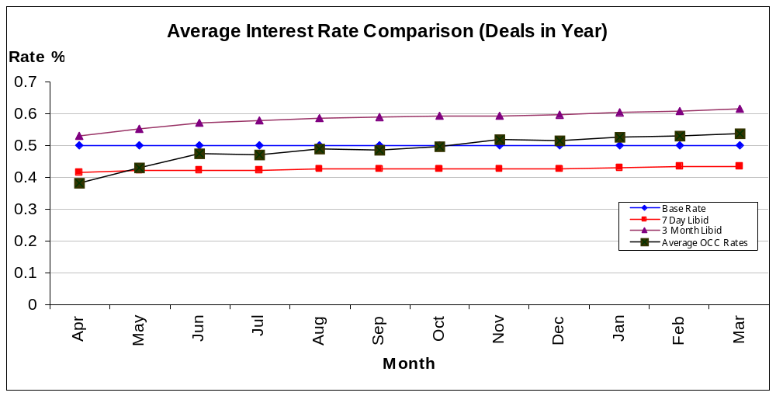
As at 31st March 2011 the year to date average rate of interest is 0.54%, this is 0.01% up on February 2011. The Base Rate remains at 0.50%.

The Council monitors its performance against the 7 day Libid rate (0.43%), unchanged from February 2011.

Business Rates

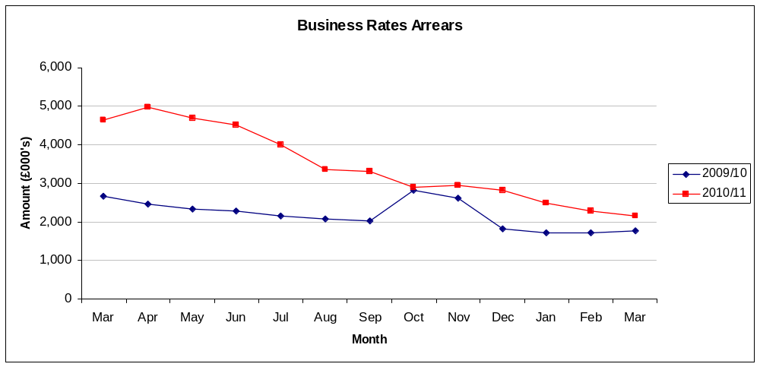

Arrears fell by £0.1m in March to £2.146m. The collection rate 2010-11 was 97.36% compared to a target of 97%

Council Tax Arrears Collection

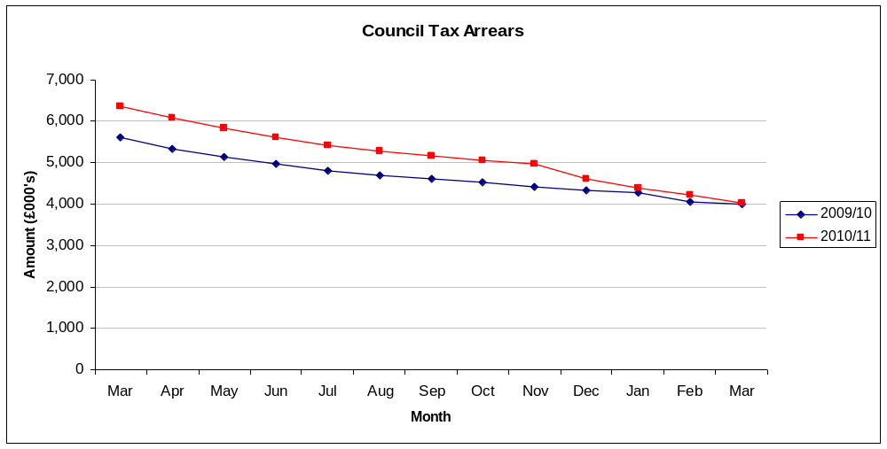
Arrears fell during March by £0.2m (£4.2m to £4.0m). The collection rate for 2010- 11 was 96.79% compared to a target of 97%.

Creditor Payment Times

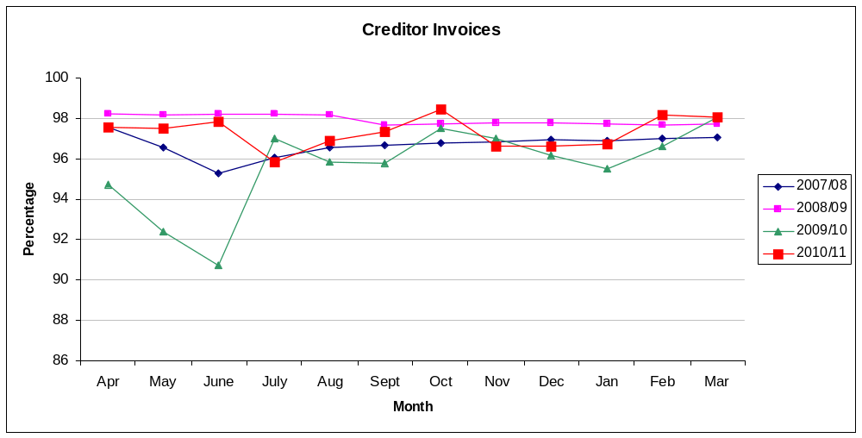

98.30% of March invoices were paid within 30 days. Over 2010-11 97.33% of invoices were paid within 30 days, this is 0.17% below the 2010-11 target of 97.5%

8 GENERAL FUND AND HRA REVENUE CARRY FORWARD REQUESTS

A total of £1.1m of carry forward requests have been recommended for approval by the Head of Finance. £1m of this relates to the General Fund with the remaining £0.1m attributable to the Housing Revenue Account Appendix E sets out the detail of all carried forward requests

Table 7 – General Fund and HRA requests to carry forward unspent balances

 |  | CMT
Directorate |  | Recommended
 |  | £
Finance and Efficiency |  | 27,000
City Services |  | 136,950
City Regeneration |  | 88,035
GF Transformation Projects |  | 711,632
Total General Fund |  | 963,617
HRA |  | 181,409
Total |  | 1,145,026

The General fund and HRA surplus as reported above assume that these carry forwards have been approved.

- IMPACT ON FUTURE BUDGETS

General Fund
A number of the outturn variations identified above for 2010/11 are either one-off in nature or have been allowed for in the councils Medium Term Financial Strategy such as unachieved savings and car parking pressures, there are no ongoing pressure from 2010/11 which should give cause for concern in 2011-12.

Capital
On capital over £3 million under spend has been identified mainly within Housing Revenue the resources for which will be used to support the HRA capital programme for future years

HRA
There is an ongoing pressure on the HRA of around £600,000 which has arisen due to the reduction in overheads charged to capital, which for 2010/11 was partially mitigated by reductions in planned maintenance, revenue repairs and holding of vacancies. The rent increase in 2011-12 will absorb some of the pressure going forward and any additional pressure will need to be taken into account in a refresh of the Medium Term Financial Plan

Name and contact details of author:-
Name: Nigel Kennedy
Job title: Head of Finance
Service Area / Department Finance and Efficiency
Tel: 01865 252708 e-mail: nkennedy@oxford.gov.uk

